

Financial Period Close
User Guide

Updated: July 7, 2025

Contents
Statement of Purpose 3
Reconciliation of Financial Accounts 3
Financial Statement Navigation 3
Income Statement Details & Reports to Review 4
Balance Sheet Details & Reports to Review 5
Balance Sheet & Reports 5
Additional Reports to Reconcile 10
Reconciliation Reports 10
Period Close 12
Period Close Checklist 12

This document is intended solely for the use of authorized clients of PracticeERP. Unauthorized access, distribution, or use of this document is strictly prohibited. The information contained herein is confidential and proprietary to PracticeERP. Any attempt to reverse engineer, decompile, or disassemble the software described in this document is expressly forbidden.

Statement of Purpose
This Financial Period Close User Guide is to help to identify the steps needed to close the period (month, quarter, year) by the organization’s Controller or CFO. This guide includes which reports are used to reconcile the financial statements and how to close accounting periods.

Reconciliation of Financial Accounts

Financial Statement Navigation
Account details can be found by selecting the amount for an account (from the income statement).
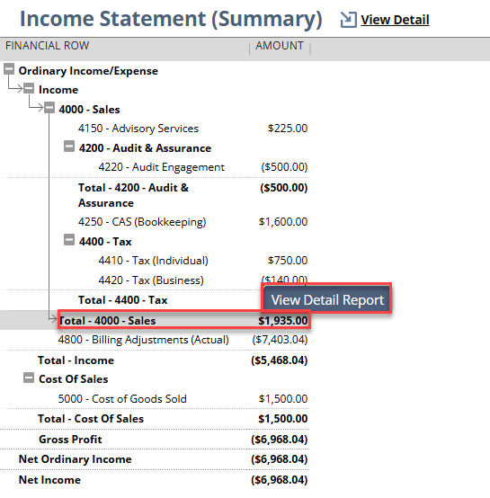
The Detail Report can be exported to Excel by selecting the Excel icon or the CSV icon. Both icons are in the lower right corner of the report.
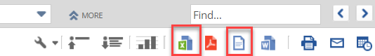

Income Statement Details & Reports to Review

If you are not recording revenue at the time of WIP, then you should use these reports to reconcile with your Income Statement.
- Revenue by Client (GL > Reconcile Reports)
- Revenue Reconciliation reports (GL > Revenue Reconciliation)
EXCEPTION: Any recorded revenue not tied to a Client will NOT be on this report.

If you are recording revenue at the time of WIP, then you should use these reports to reconcile with your Income Statement.
- WIP menu > Open WIP > Reconciliation reports (either last month or YTD, depending on what period you need). The Production amount should tie to Total – Income on the Income Statement.
- Also, G/L > Reconcile Reports > Monthly JE (WIP Date) should tie to the Total – Income line on the Income Statement.
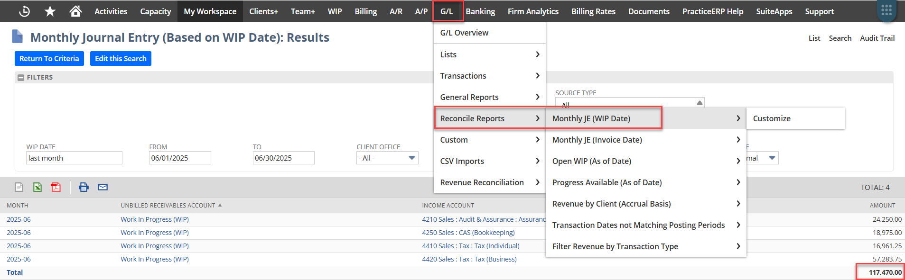

If the Revenue amount on the Income Statement does not tie to the Reconciliation reports, then we recommend you review the following reports for discrepancies.
- Review the Income Statement Detail for transactions (including journal entries) that are not invoices or the journal entry to record WIP.
- Use the WIP Billing Date Not Equal to Invoice Billing Date search (see on page 8 for more information) to identify any date mismatches.
- Use the Transaction Dates Not Matching Posting Periods report (see on page 8 for more information) to identify which invoices impacted the income account.

Balance Sheet Details & Reports to Review

Balance Sheet & Reports
Review account details by clicking on the Amount column for an account (from the income statement). This will display a Detailed Report of the account selected.
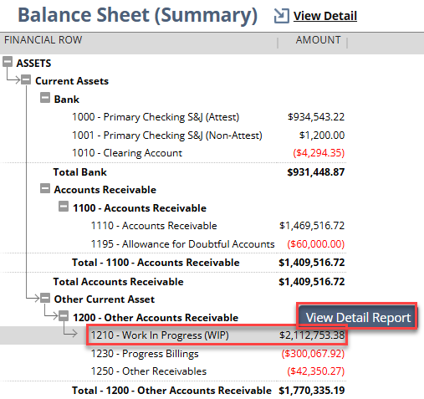

The Detail Report can be exported to Excel by selecting the Excel icon or the CSV icon. Both icons are in the lower right corner of the report.

Bank Accounts – Balanced via bank reconciliation.
Reference this video for more information on Bank Reconciliation, also available in PracticeERP Help: https://assets.gvo.cloud/practiceerp/videos/Bank_Reconciliation.mp4.

Accounts Receivable
Review the following Accounts Receivable reports at A/R > Aging Reports.
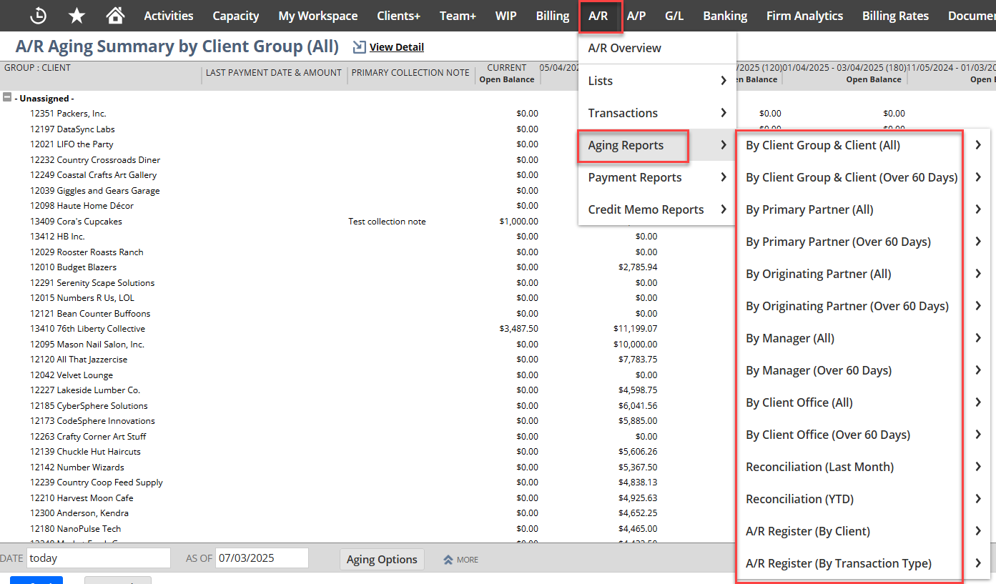
Unbilled Receivables/WIP (usually an Other Current Asset)
The Open WIP - As Of Date view is where the unbilled receivables can be accessed to view your month end WIP balances.

Instructions
- G/L > Reconcile Reports > Open WIP (As of Date)
- WIP > Open WIP > Open WIP (As of Date)
- Open the Filters section (click the + to the right of FILTERS)
  - Modify the first To filter to equal the end of the month you want to view.
  - Enter the second From filter to equal that same date.
  - Press the Tab key to view the results.
An example, in the following screenshot see the Open WIP as of the end of June 2025. The only filters that need to be populated are marked with 1 and 2. These filters MUST equal the same date. The Total Open WIP as of the end of June was $445,084.50, in the bottom right corner.

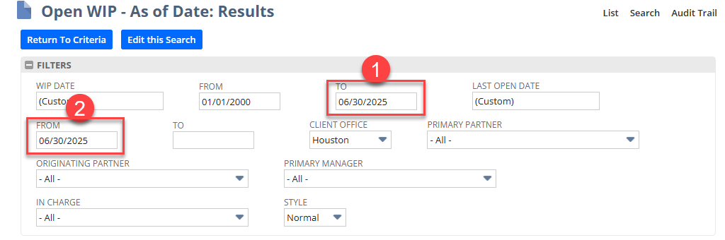
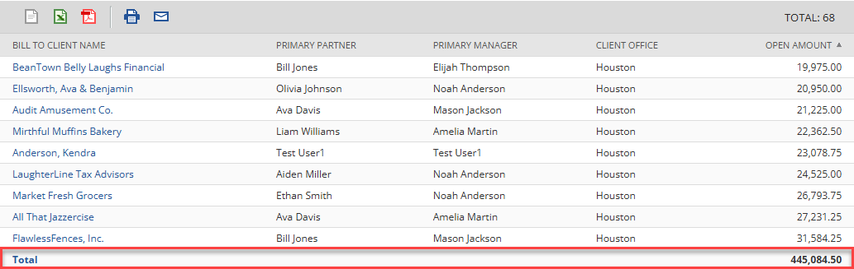

If the Open WIP (as of date) saved search results do not tie to the Balance Sheet, then run the WIP Unbilled Receivables Account Validation search (see page 8 for more information).

Progress Billings
The Progress Available search results may have two accounts for some firms: Attest and Non-Attest.
Progress Available (As of Date) should be reviewed at G/L > Reconcile Reports (other Progress Available reports are not as of a certain date).
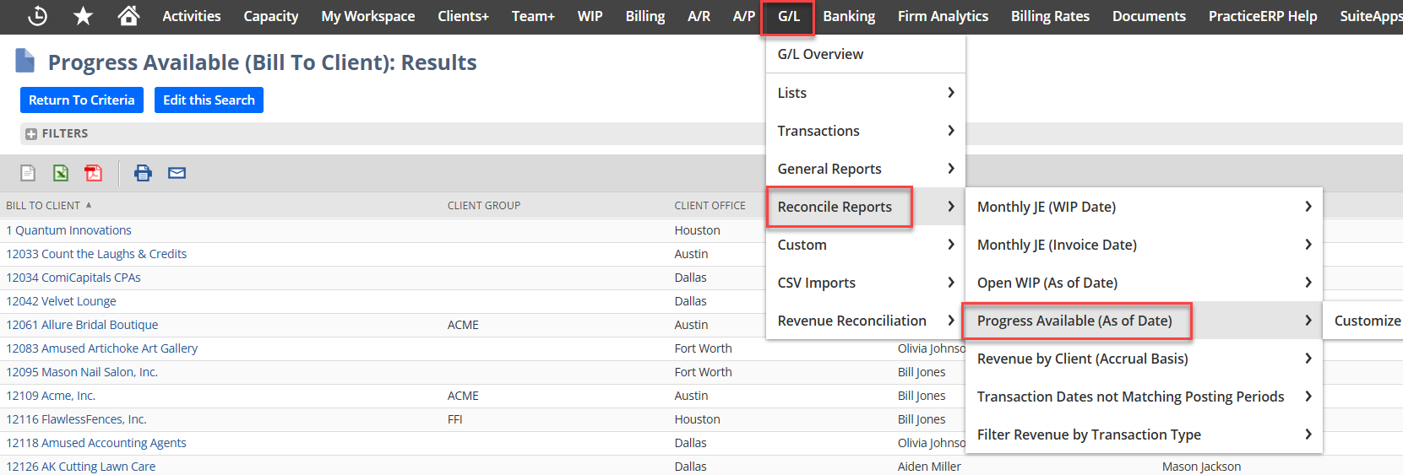
Review one month by entering the beginning of the month in the From field and end of the month in the To field, like below.
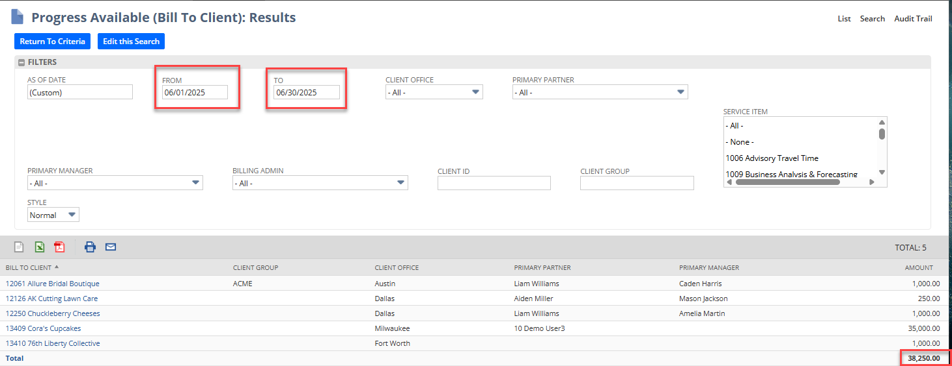
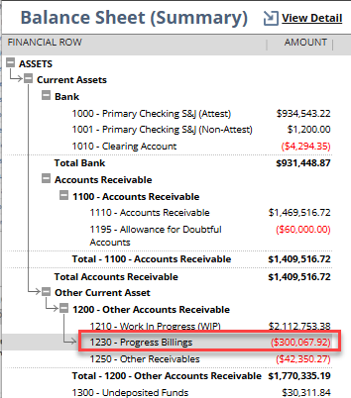
If the Progress Available search results do not tie, then run the Progress WIP account and Item Validation search (see more on the next page).

Accounts Payable
Review the Accounts Payable report at A/P > Reports > Open Bills.

Additional Reports to Reconcile

Reconciliation Reports
The following reports are all located at G/L > Reconcile Reports.
- Transaction Dates Not Matching Posting Periods – identifies invoices by Client during the specified period.
- WIP Billing Date Not Equal to Invoice Billing Date – identifies any WIP where the billing date stamped on the WIP record does not equal the invoice date. This can happen when the invoice is changed after it’s saved. If there are no results for this search, then this means all dates match.
- WIP Unbilled Receivables Account Validation – identifies any WIP where the unbilled receivables account is not correct and thus not being correctly identified on the balance sheet. If there are no results for this search, then this means all WIP is in the correct unbilled account.
- Progress WIP account and Item Validation – identifies any Progress WIP that is not using the correct income account or service item. If there are no results for this search, then this means all Progress WIP is correct.
- Accounts Receivable No Client – identifies any AR balances that do not have a client assigned. This commonly occurs after a go-live when AR balances have been imported.

The following reports are in the Clients+ tab.
- Raw Production - This view displays billable hours and product amount by various groupings.
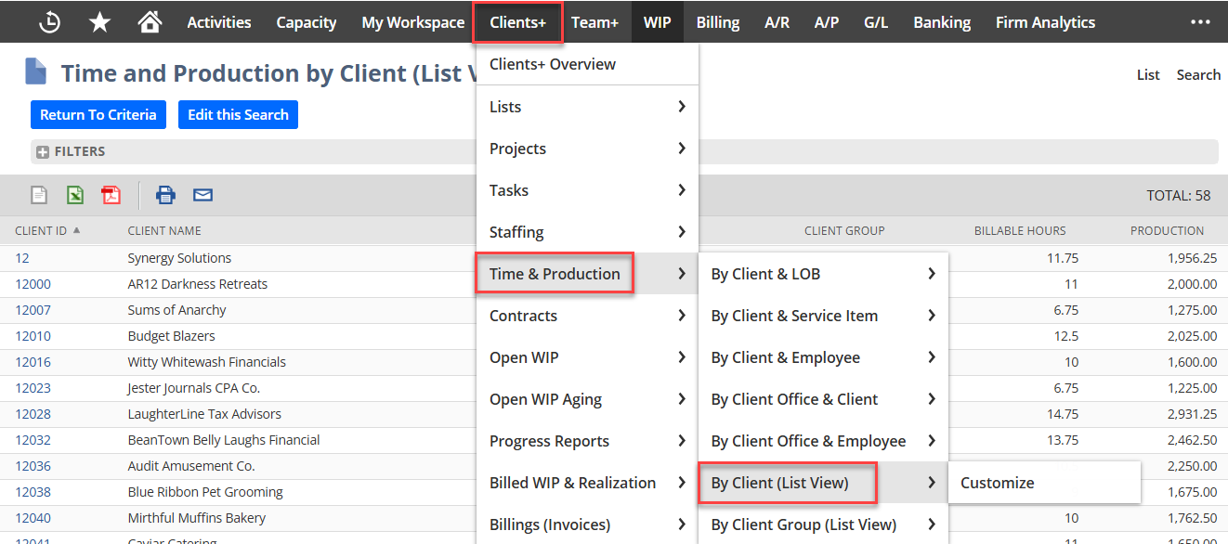

- Write Up / Write Down / Realization - This view is similar to the previous report but contains all WIP (not just WIP from time) plus any write ups or write downs. This view also includes the realization percentage.
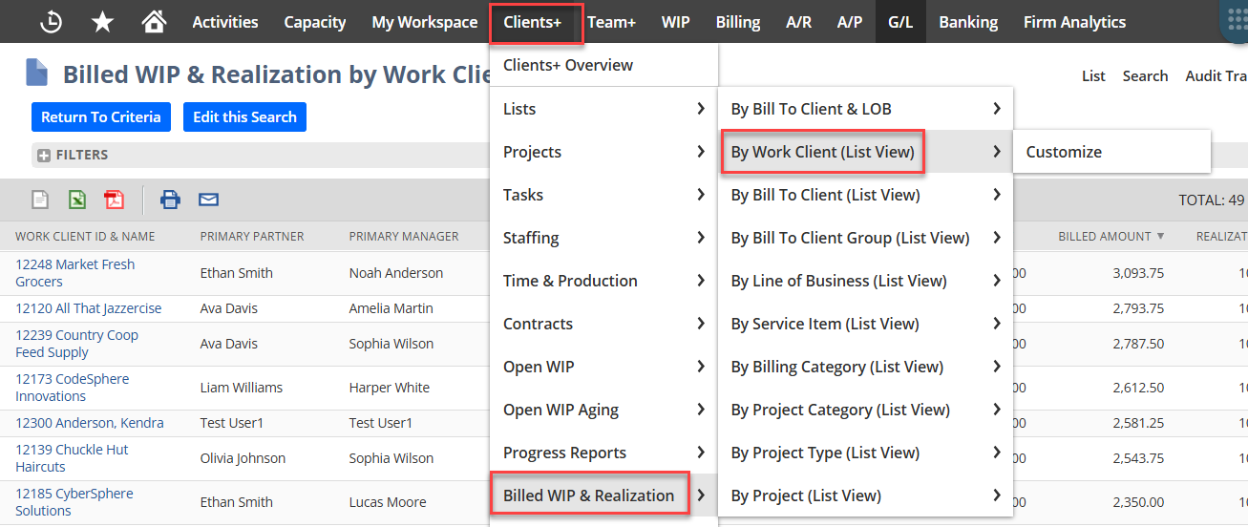

- Aging Reports to Reconcile
  - Open WIP Aging - Clients+ > Open WIP Aging
  - AR Aging
  - AP Aging

Period Close

Period Close Checklist
Once the financial statements are created, reconciled and all transactions for the period are entered, each month should be closed.

NOTE: Users will need to use the Controller/CFO (All Subs) role to be able to close all subsidiaries.
- Navigate to G/L > Lists > Manage Accounting Periods
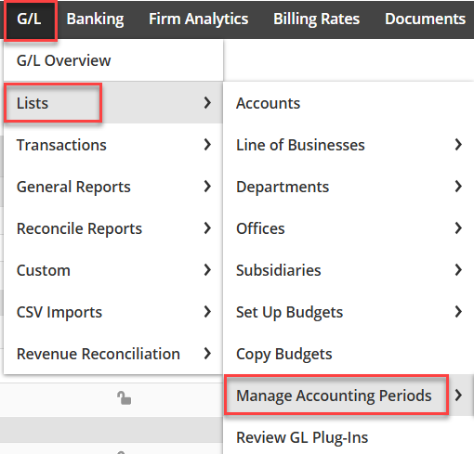

- The Manage Accounting Periods page shows a list of all available accounting periods.
  - The Checklist column contains the link to the checklist of tasks that need to be performed to close a period.
  - The Period Close column will contain a green checkmark to indicate which periods are closed.
  - The A/P Transactions, A/R Transactions and All G/L Transactions columns will contain a lock icon to indicate that type of transaction is locked for that period.
  - The Allow Non-G/L Changes column will contain a checkmark if the user has the ability to post or edit transactions that do not impact the GL.
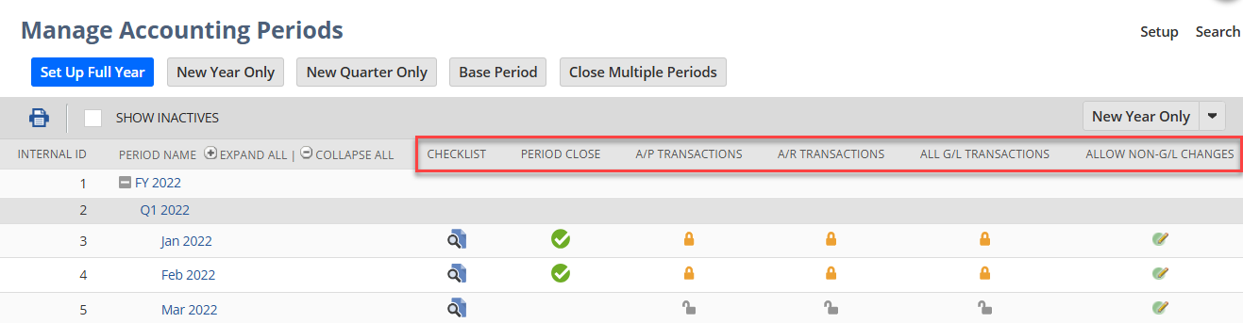

- Periods must be closed in chronological order. Navigate to the oldest period without a checkmark in the Period Close column and click the Checklist icon to view the Tasks that must be completed.
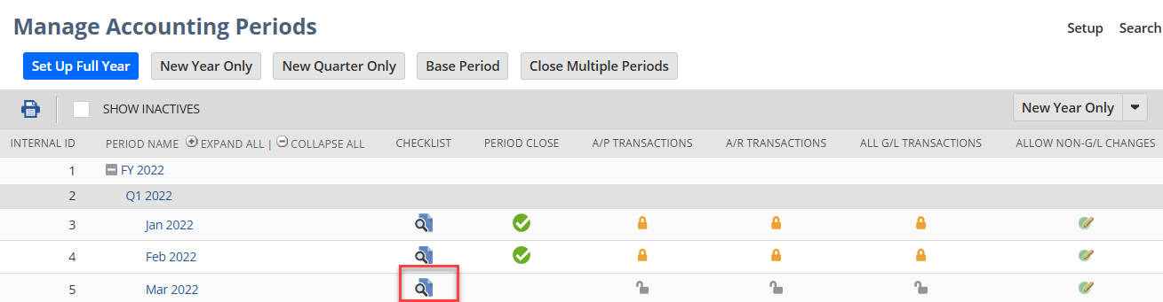

- Click the green arrow under the Go To Task column to open each task. Note that the Close task does not become available until all previous tasks are complete.
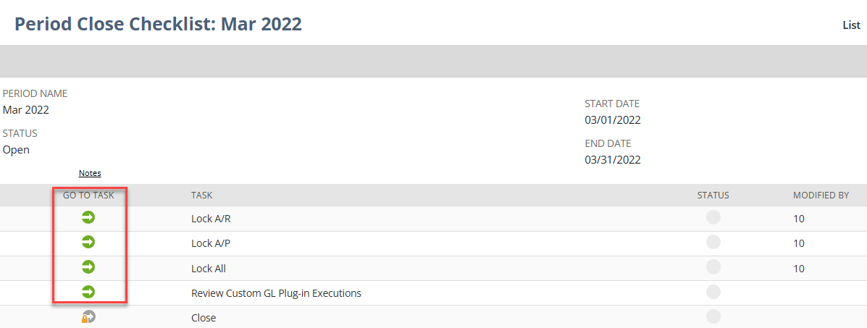

- Within each task, checkmark each Subsidiary to close and click Submit.
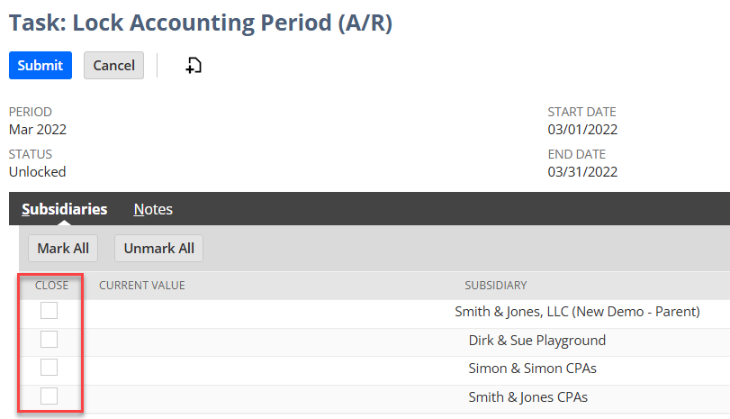
NOTE: Individual subsidiaries can have AR, AP and GL locked independently of each other, however the period cannot be fully closed until all subsidiaries are locked.

- The Review Custom GL Plug-in Executions task requires you to click the Review Custom GL Plug-in Executions button, select Back to Period Close, then click Mark Task Complete.
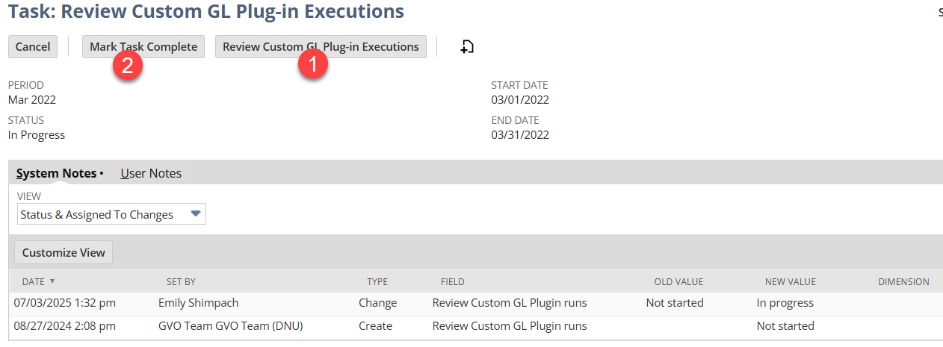

- Once the Lock A/R, Lock A/P, Lock All and Review Custom GL Plug-in tasks are marked Complete (indicated by a green checkmark in the Status column), then the Close task is unlocked (see screenshot on next page).
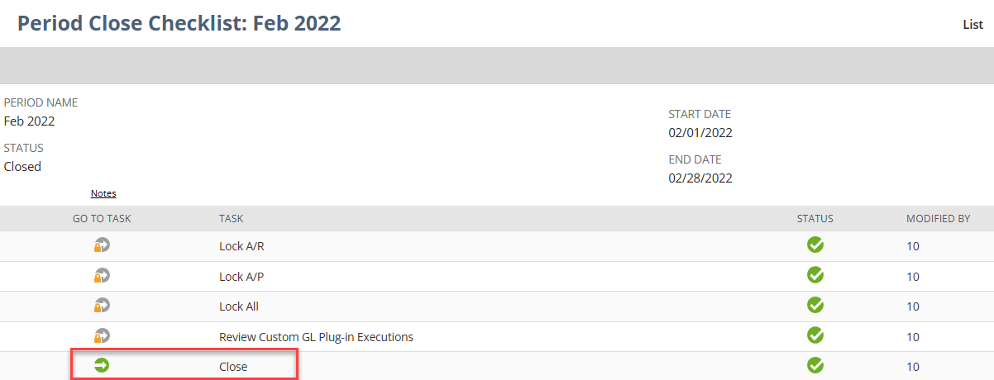

- Once the Close task is complete, the above tasks become locked. A user would need to undo the Close task to open the remaining tasks.
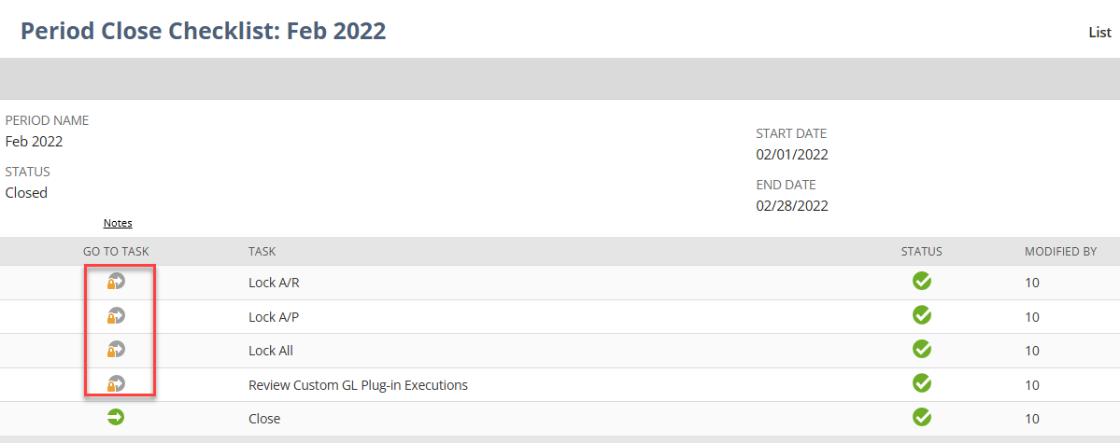

- Once all the tasks are closed, the period is locked.


