Refunds
For credit card refunds.
- If a payment was applied to an invoice you should unapply it.
- If you are refunding the payment and they do not owe the invoice you would then credit memo the invoice so that is at $0.
- Refund through credit card processor
- Go to Banking, Transactions, Deposits (This will help balance the bank account to remove the money from the client by. Need to do this steps when you are entering all credit card payments so that they are all part of the same batch)
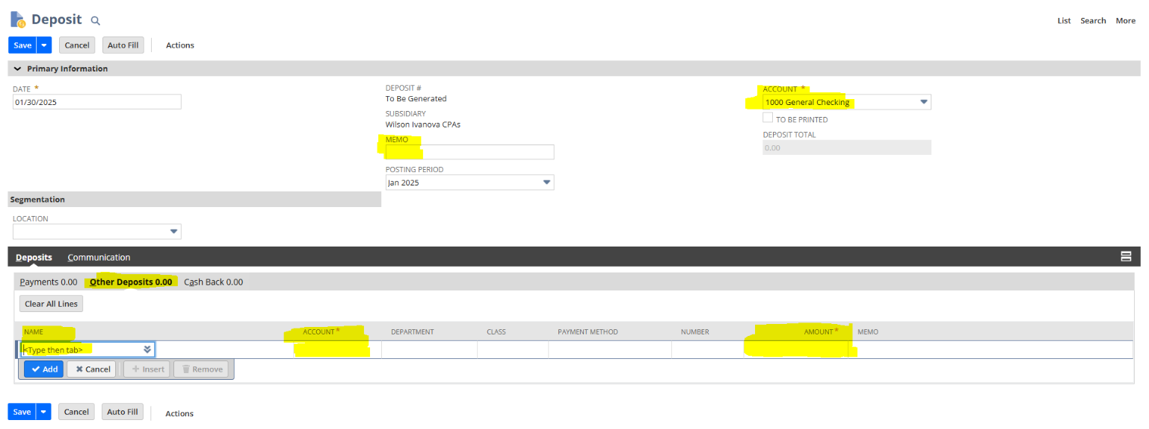

  - Fill out the highlighted portions and ensure you have the right accounts picked for the refund and enter in a negative amount. Save
- Then go to AR, Transactions, Accept Client Payments
  - Fill out and verify the highlighted filters:
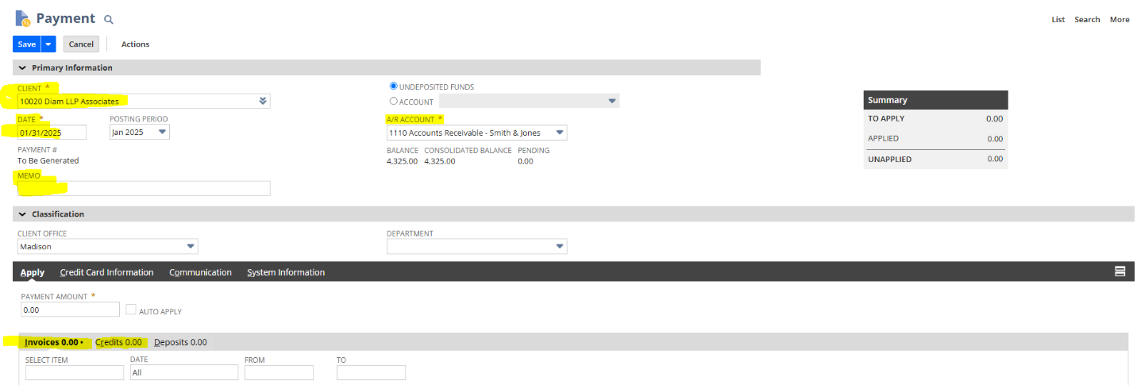

  - Since you have already done the deposit it would list the refund on the invoice tab, select that item. Then select the credit tab to apply the refund to the original payment. (Once you have done both tabs the Payment Amount should be at $0.00) Save
Check Refund
- If a payment was applied to an invoice you should unapply it.
- If you are refunding the payment and they do not owe the invoice you would then credit memo the invoice so that is at $0. The payment would then be sitting as a credit on their account.

3.) To write them a check back go to Banking > Transactions > Write Check
a. Fill out the highlighted items below.
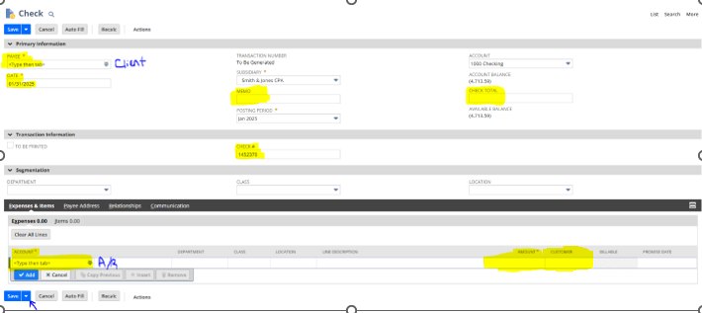
b. Make sure that you are entering your true check number that you are writing to the client. Fill out the other boxes as described and also put in the client in the customer section next to the highlighted Amount at the bottom. When done click the drop down next to save and select save and print so that the check prints right away.
4.) Then go to AR, Transactions, Accept Client Payments
  - Fill out and verify the highlighted filters:
  - Since you have already done the check it would list the refund/check on the invoice tab, select that item. Then select the credit tab to apply the refund/check to the original payment. (Once you have done both tabs the Payment Amount should be at $0.00) Save

